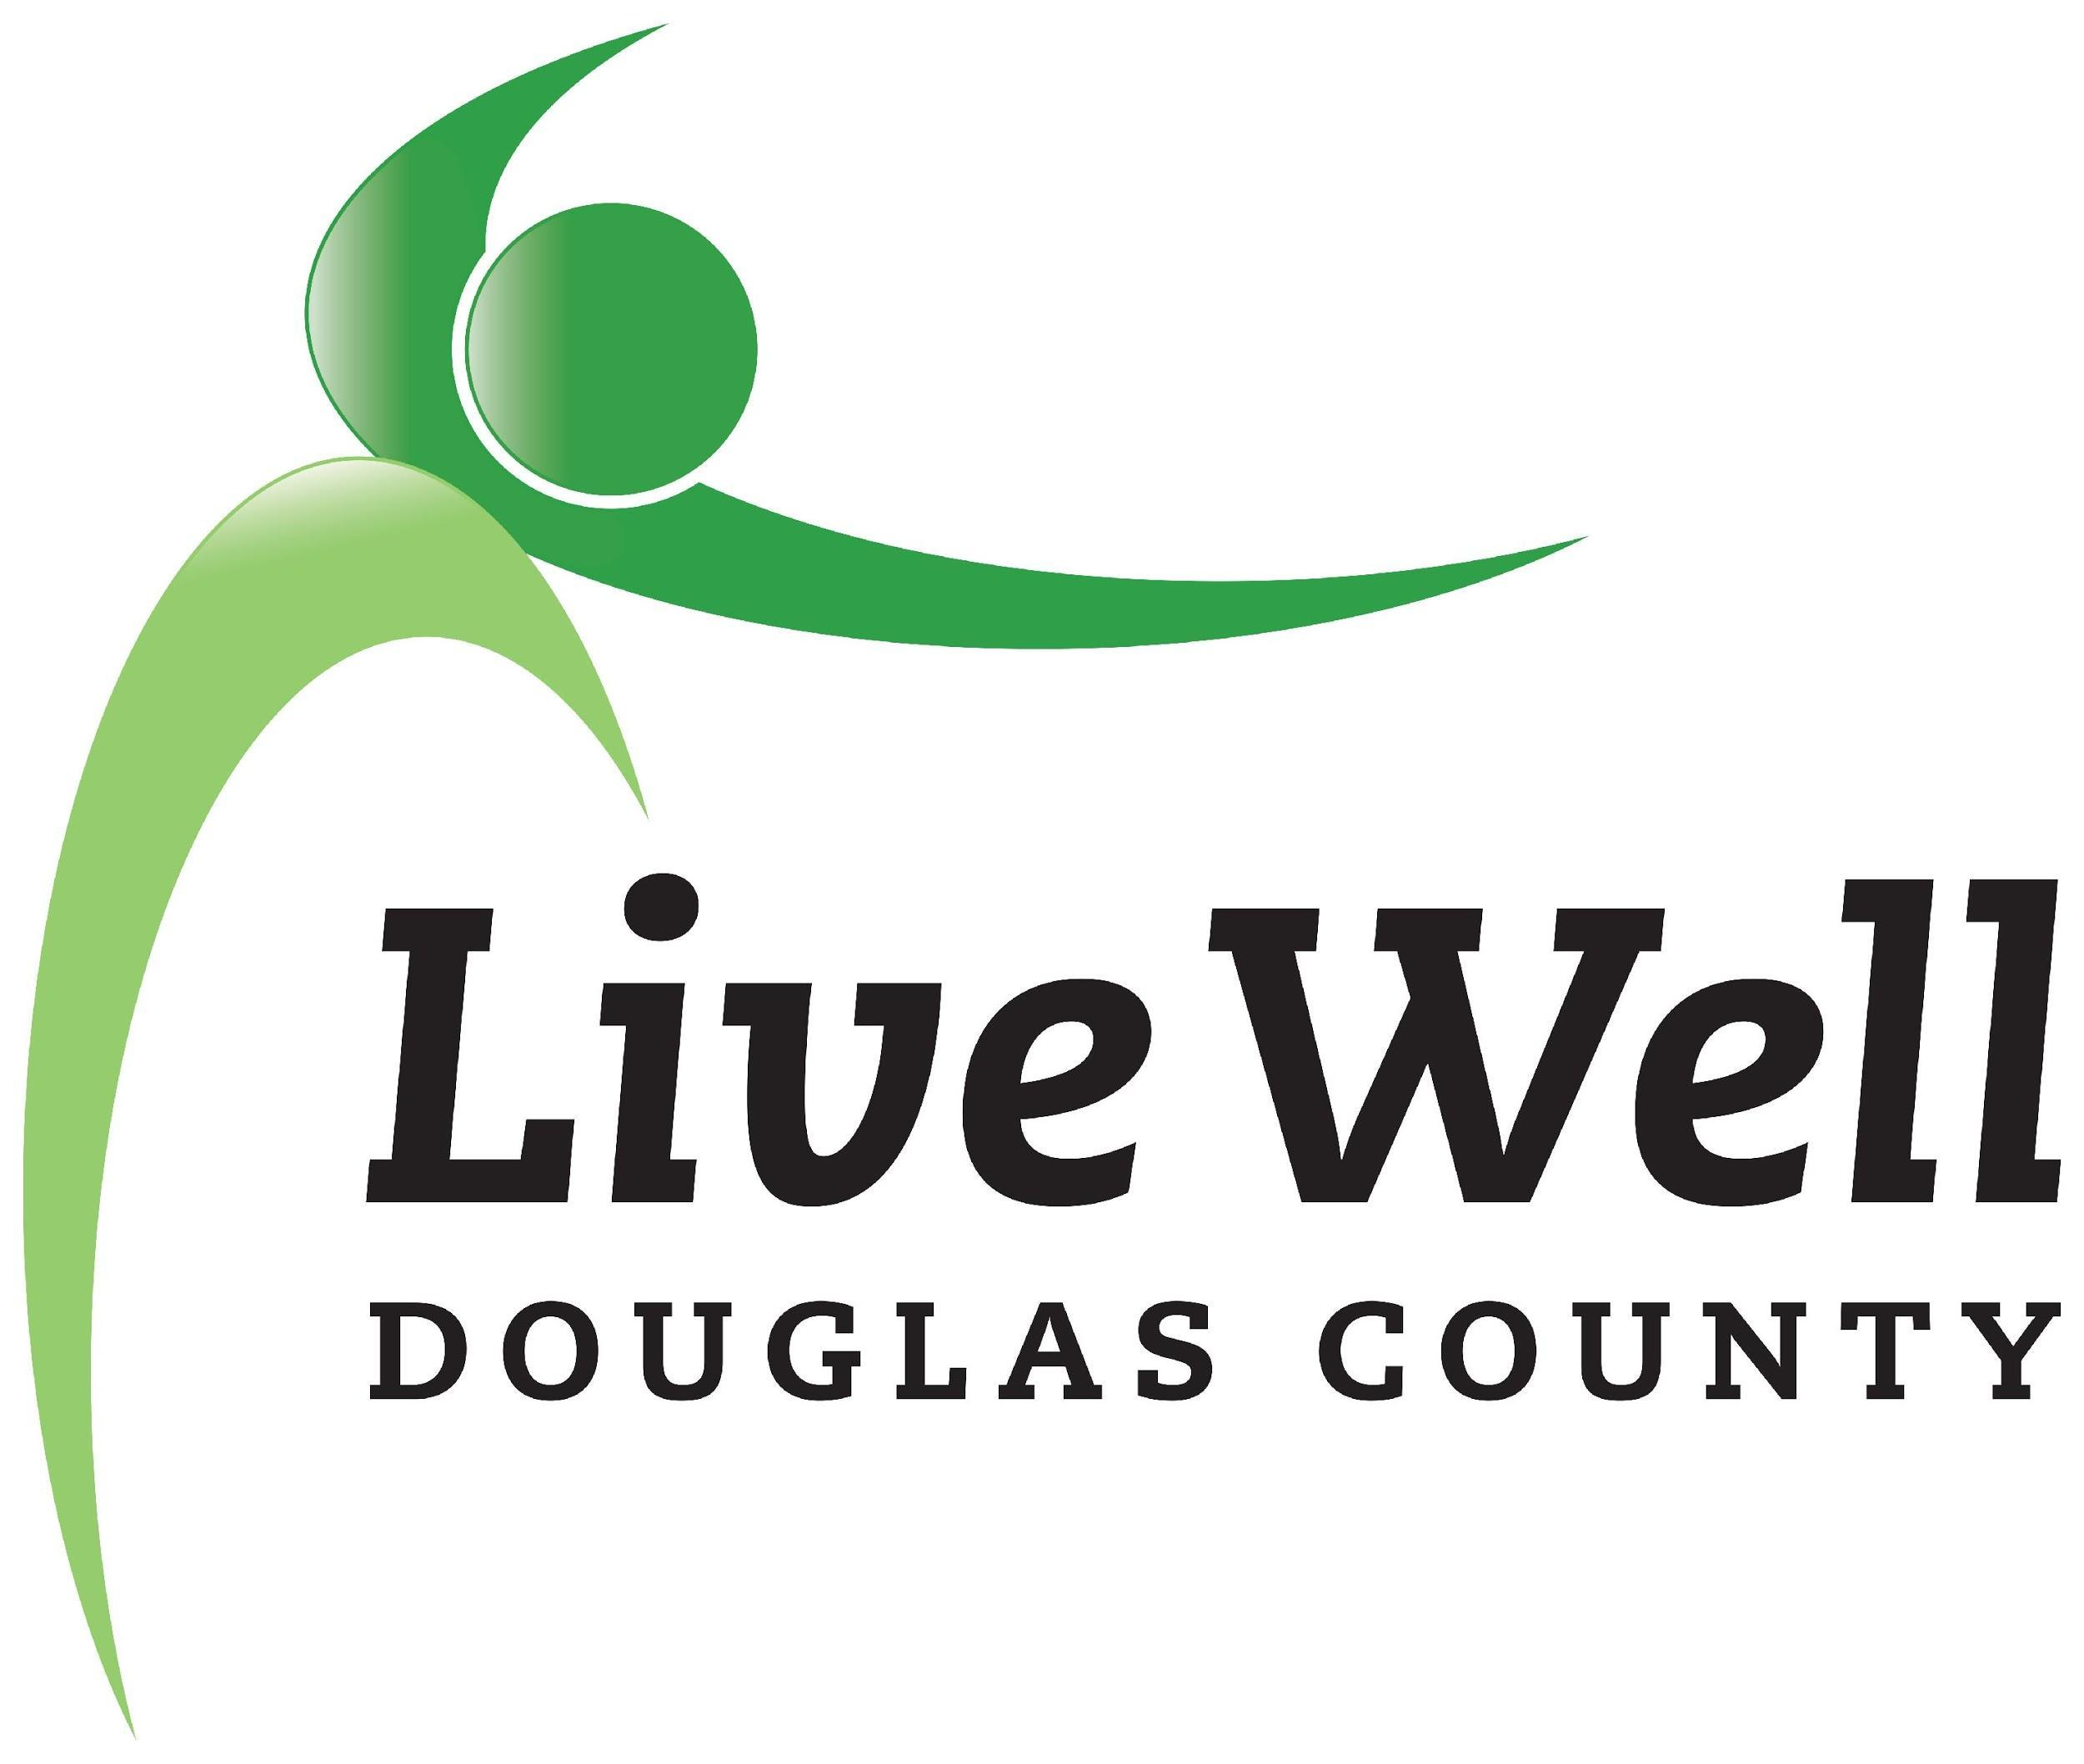
LiveWell Executive Team
Meeting Agenda

November 17, 2020, 3:30-5:00pm
Online via Zoom

Item | Notes | Action step
Review of agenda | Additions?
Annual Event | Confirm run-through, outreach  12:00pm - 12:10pm Welcome, introductions - Joey  intro Marty  12:10pm - 12:20pm Working group videos*  Marty’s speech  12:20pm - 12:30pm DCCF awardee announcements  12:30pm - 12:40pm LWDC awardee announcements - Chris  12:40pm - 12:45pm Closing, thanks - Joey | Add:  - Russ Jennings, LMH  - Allison Koonce  - Ainsley Anderson  - Erica Hill  - City/County electeds, managers, relevant staff  - Awardees follow-up (All)  Draft Email to Invite Listserv  Draft event program - in line with BCBS comms standards (Joey)  Bring one person to the event - challenge for all current coalition members (Joey)  Test video quality (Joey)
Grant(s) check-in | KDHE-SVP grant/MOU with The Care Center  BlueCross Blue Shield Pathways grant  - Action Planning process | Follow-up with Chrissy on status of MOU, response from KDHE (Marlin)  Leverage materials Marty drafted to make adjustments, prioritizations (Marty)
Structure, bylaws, collaboration | Technical assistance available through BCBS  - Capacity building, leadership, and coalition supports  - Good to consider accessing these tools now  - May help support leadership growth and transitions (a growth area cited several times as a need in conversations)  Healthy Kids Work Group  - Participation is robust, and unique  Bylaws  - Need to identified previously, put on hold as we filled the ED position  - Put on the back burner

Attendance:
Chris Tilden
Marty Scott
Christina Holt
Marlin Bates
Beth Llewellyn
Joey Hentzler

